SIMPLE copper "J" pole
by Dale “Kuby” Kubichek, N6JSX /8 03/2001
Can you use a pipe cutter or a hack saw, can you solder – then here is how to build a SIMPLE ”J” antenna that will more than double your 2 meter (and even 440) performance!
The "J" antenna goes back many years, long before I became a ham. There are a bunch of reasons why you're going to want to build one of these beauties:
“J” has the lowest angle of radiation,
“J” requires NO ground plane;
“J” is very easy and inexpensive to make;
“J” has great performance for mobile, marine, or base operations;
This “J” design can be used as a dual-band (2m/440).
Technical:
The basic "J" is reported to have >3dB of gain over a ¼ λ ground plane antenna and 6dB over an isotropic (theoretical) antenna.
Technically, the "J" antenna is an end-fed ½ λ antenna that uses a ¼ λ matching stub. Old-timers call it an "end-fed Zepp", bent 90°. In actuality, the conductor is ¾ λ long and the matching section uses the bottom ¼ λ.The matching stub creates the tuned ½ λ length antenna.
Due to the matching section acting as the matching transformer, the ½ λ radiator sees the lower ¼ λ matching section as an image of a false ground plane. In best terms, the "J" is a balanced ¼ λ matching stub feeding an unbalanced ½ λ load.
The feed-lines to a "J" can be almost anything (ladder line to coax). However, in experimentation, I found RG-58/U coax to be best when used at odd ¼ wave multiples.
A “J” is the best for mobile and marine application where you want the most distance across relatively flat ground/water. A 5/8 or ¼ λ antennas have a higher angle of radiation and need to be centered on a good ground plane eliminating gutter or vehicle edge mounting to obtain optimal performance. A "J" requires NO additional ground plane.
A “J” has an exceptionally low, to nearly flat, angle of radiation of about 0-2 degrees. The 5/8 λ has about a 3-6 degree radiation angle and the highest radiation angle comes from the ¼ λ that has about 4-10 degrees. These two antennas are usually better for mountain top (a few thousand feet elevated) repeater site use but will fall far short of a “J” in overall flat-land transmitting distance.
The pictured “J” is at 60’ on top my tower in Manitowoc, WI. I can now hit repeaters across Lake Michigan, Milwaukee, or Upper Michigan that are well over 85 miles away.
Parts:
- One 10 foot piece of thick wall ¾” rigid copper pipe
- One ¾” copper pipe “T”
- One ¾” copper pipe 90° elbow
- Two ¾” copper pipe caps
- One SO-239 connector
- One 3” piece of copper wire
These parts and plumbers flux, plumbers solder, and propane torch can be obtained at most hardware stores.
Using copper pipe makes it easy to solder and snap to assemble. These materials will withstand a lot of abuse and weather.
Total cost of this antenna (not including tools) was about $34.00 using 3/4 inch copper pipe. (KI7LYP)
Total cost of this antenna (not including tools) was about $17.00 using 1/2 inch copper pipe. (KI7LYP)
NOTE - about dimensions:
In general, if you follow the dimensions I have included here you will have an antenna that will be less than 2:1 VSWR and more like 1.5:1 VSWR across the 2-meter band.
Recently, I have been experimenting with the basic “J” dimensions; I have found that a 2m J length of 63” really enhances the 440 band operation (63”=2.5 l at 445). The trade-off on 2m is an enhancement of a much wider bandwidth and an overall lower 2m VSWR. My J design dimensioned here is really great for single feed dual band operations

Building: Basic dimensions for a ¾” rigid copper pipe “J”

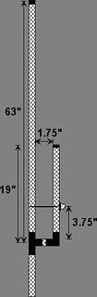 | 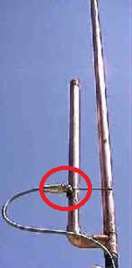
The difference of this design over my previous designs is the change to the feed point attachment method. I did not like soldering the coax wires directly to the copper pipe these wires were exposed to the elements. The coax got very brittle, the center dielectric crack, and the coax eventually got water logged.
NOTE: BEWARE of your heat used when soldering the SO-239 to the “J” or the center conductor insulator in the SO-239 will melt away or go off center! (Notes 1&2)
I take a wire wheel and steel wool to make my copper “J” antennas giving them a near military shine. Then I put multiple coats of Varithane (non-UV type) spray or Marine Spar varnish over the entire antenna - this will keep the antenna bright and tarnish/rust free for years. I even do this to my aluminum beams.

Performance Data
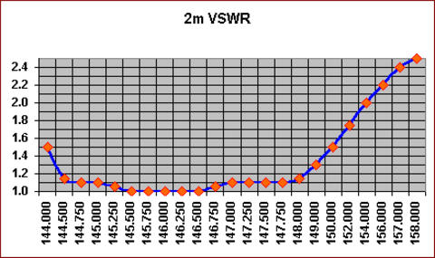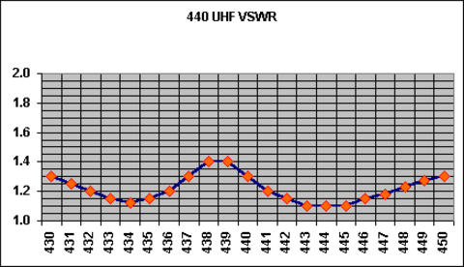
I have found that the length of the attached coax does have an effect on the J’s VSWR. Multiples of odd ¼λlengths seem to minimize these coax affects. I have pruned off 3” pieces of coax in the HAM shack to bring the VSWR back to the 1:1 tuning the antenna was setup at.
On VHF/UHF the VSWR variances are very susceptible to the consistency of the coax velocity factor and quality. (Note 3)
I have used copper pipe “J” in an apartment placing the antennas in the corners of the living room or hanging the "J" from curtain rods behind the curtains. I have even made a corner hat & coat rack from a copper pipe “J”.
The original version of this document (without modifications) is located at http://www.eham.net/articles/2418.

The following notes added by KI7LYP
Hint – First, solder the “tee” onto your pipe
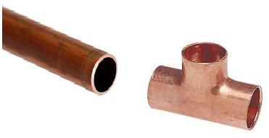
Hint – Second, solder the “elbow” onto the other end of your pipe
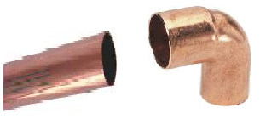
Hint – Third, measure and cut the pipe to correct lengths

NOTE 1: One error in the image is the SO-239 (circled in red) is soldered to the short section. The SO-239 should be soldered to the 63” section for better performance.
NOTE 2: If you want to solder the SO-239 directly to the copper pipe section, I have found that screwing the outer shell of a PL-259 onto the SO-239 first will act as a heat sink and help prevent damaging the SO-239, but excessive heat will still damage the connector.
NOTE 3: Make a coil of about 5 loops of coax with a coil diameter of about 6 inches. This coil should be located about a foot away from the feed point of the antenna. Secure the coil with cable ties or electrical tape.

If you would like to play with other frequencies, here is a great calculator for building a monoband copper cactus J pole http://www.hamuniverse.com/jpole.html

